**IEO REPORT**

Week 7 – Week 10



Student Name : Tobias Halomoan

Student Number : **4252861**

Class : **P-CB-06**

**Fontys University of Applied Sciences**

**Eindhoven – Netherland**

**2020-2021**

Contents of The Report

Revision Table 3

Introduction 4

WEEK 7 - NetworkBasics 5

WEEK 8 - IP 10

# Revision Table

|  |  |  |  |
| --- | --- | --- | --- |
| **WEEK** | **Name of The File** | **Date** | **Time** |
| Week 7 | Report Week 7 – Week 10 | Saturday,24/10/2020 | 15 : 20 |
| Week 8 | Report Week 7 – Week 10 | Monday, 01/11/2020 | 16 : 37 |
| Week 9 |  |  |  |
| Week 10 |  |  |  |

# Introduction

Networks are an essential infrastructure for computer systems. Every day, many computers interact with each other and transfer information through our networking systems. By using Wireshark and Netkit, we will create a simulated networking environment.

Through the simulation, we will see how exactly network nodes, IP and MAC addresses, and trafficking mechanisms interact with each other. Every week, an assignment will be done using Netkit, and this report will serve as a general overview of the collection of assignments as well as a full analysis on network infrastructure.

# WEEK 7

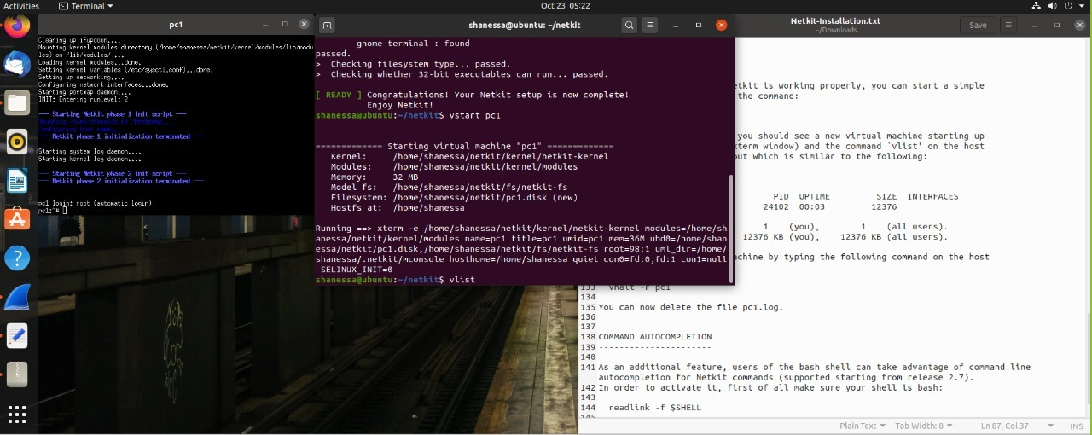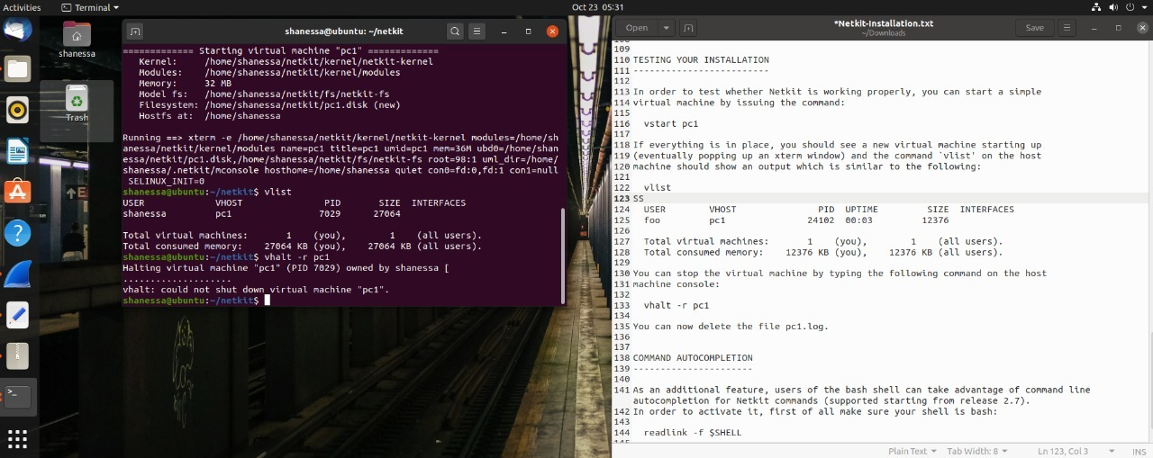

Task 2: TCP/IP Layers in Wireshark

* What is the source and destination MAC address of this HTTP packet?

Source MAC address: **00:50:56:c0:00:08**Destination MAC address: **ff:ff:ff:ff:ff:ff**

Provide a screenshot below with the Wireshark snapshot and highlight these addresses:

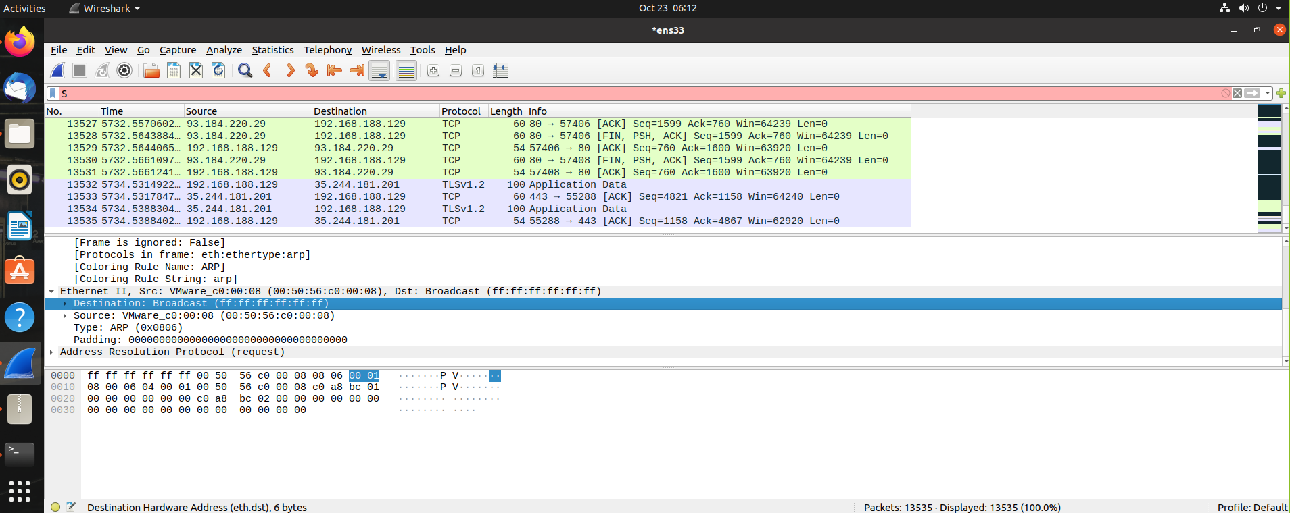

* What is the source and destination IP address of this HTTP packet?

Source IP address : **192.168.188.129**  
Destination IP address : **93.184.220.29**

Provide a screenshot below with the Wireshark snapshot and highlight these addresses:

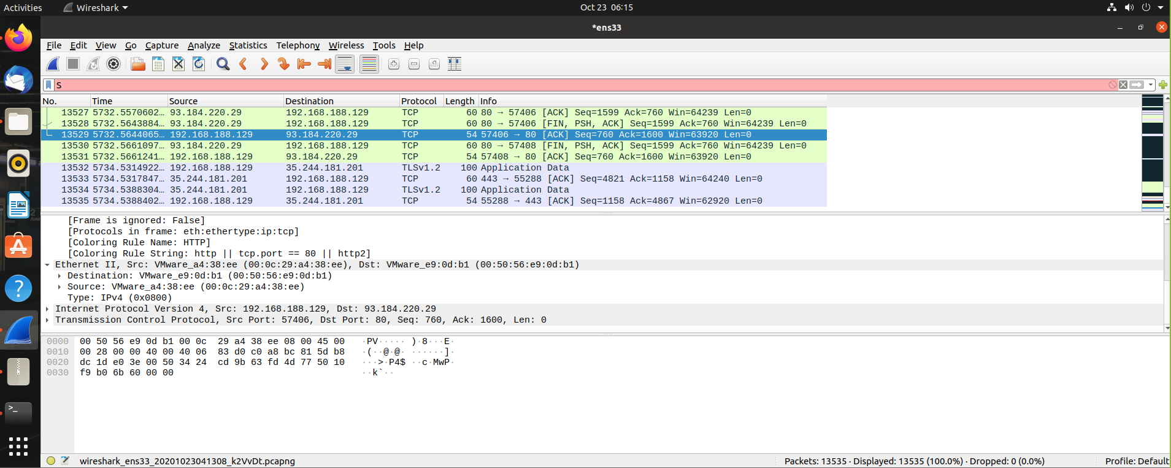

* What is the source and destination port of this HTTP packet? Provide a screenshot to prove it

Source port : **57406**  
Destination port: **80**

Provide a screenshot below with the Wireshark snapshot and highlight these addresses:

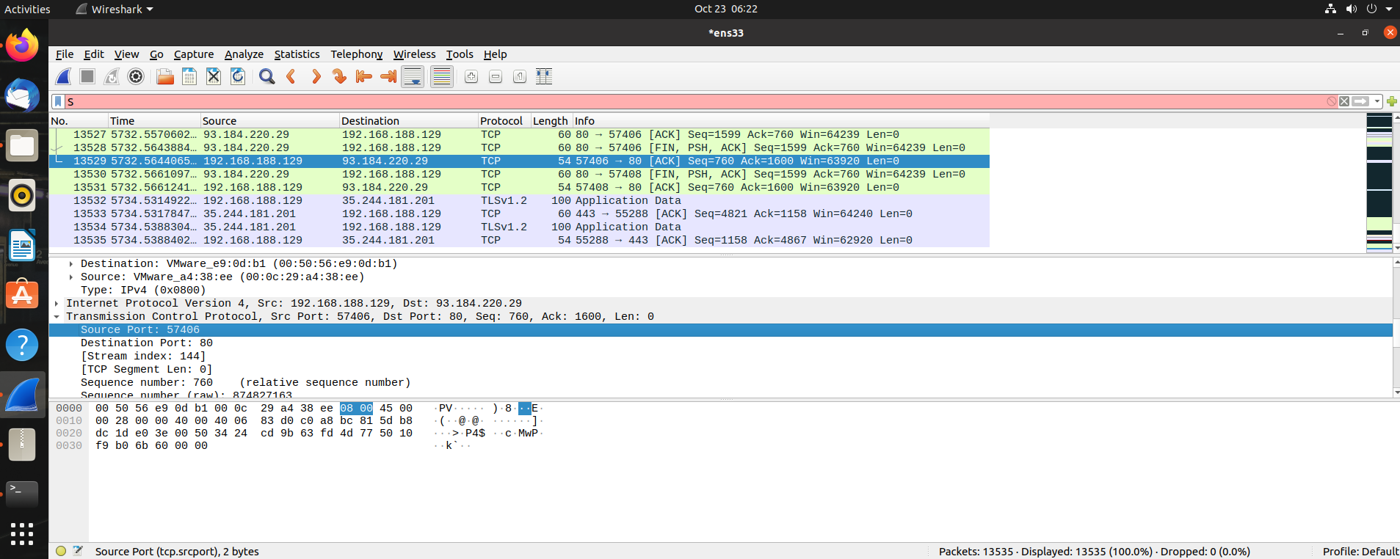

* What is the host name of this HTTP Get packet?

Host name: **ubuntu**

Provide a screenshot below with the Wireshark snapshot and highlight the host name:

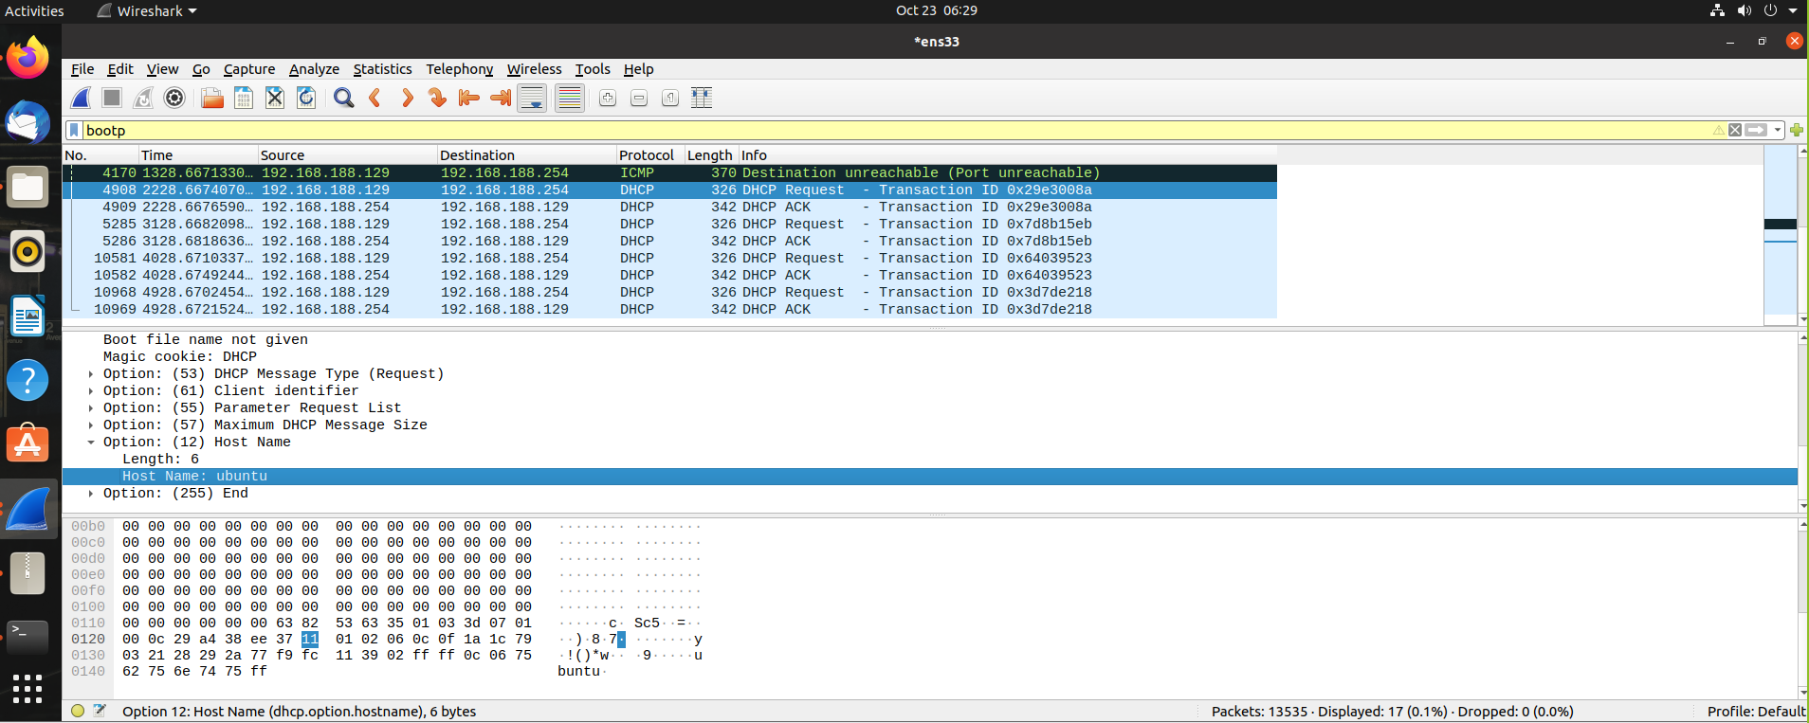

* Find the HTTP Response belonging to the HTTP Get packet. How much time elapsed between the HTTP Get and HTTP response?

Time elapsed: **1.125780448 - 0.000103813 =** **1.125676635**

Provide a screenshot below with the Wireshark snapshot and highlight the elapsed time:

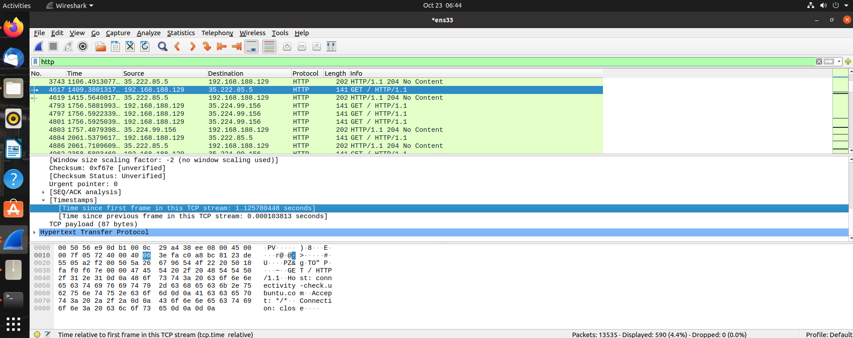

Provide screenshots of all exercises in section 3.4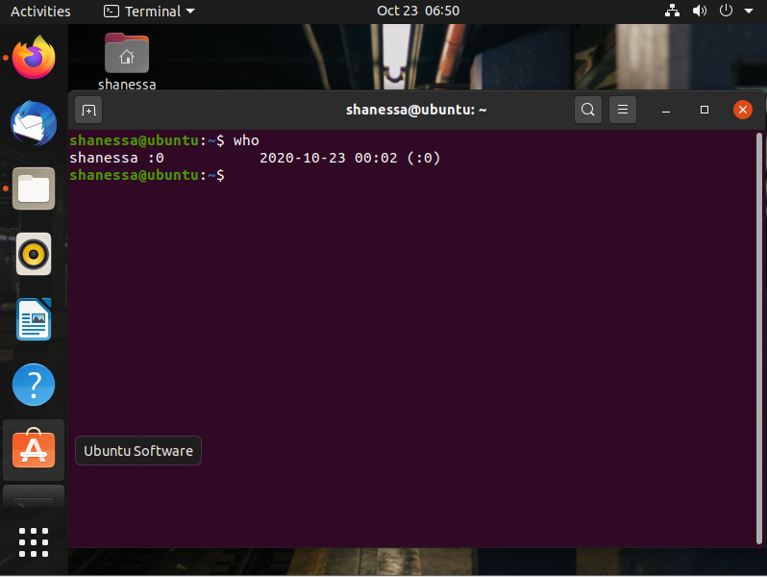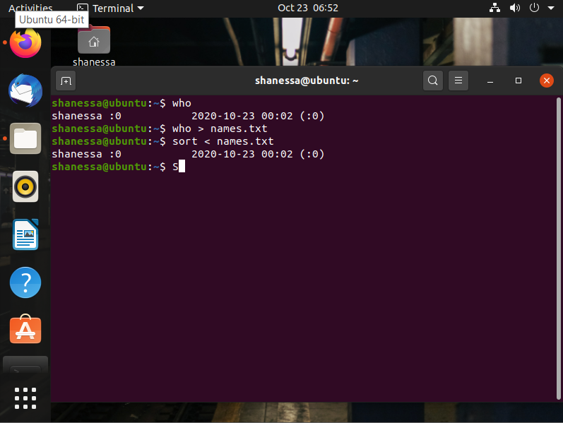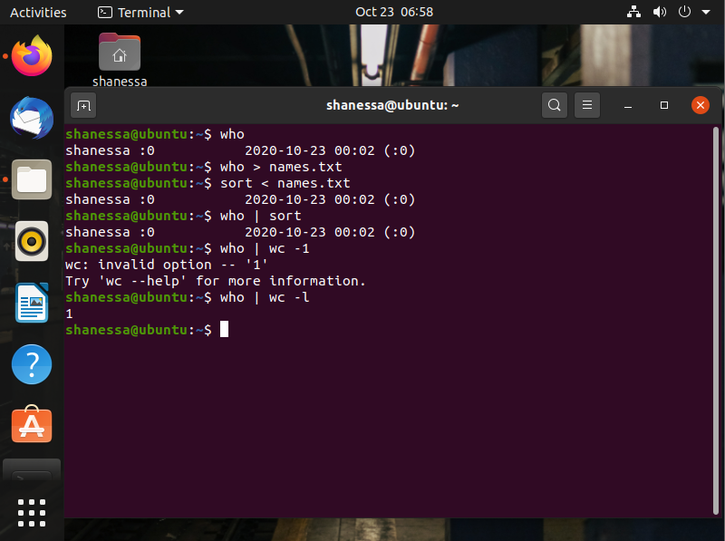

# WEEK 8 - IP

Linux, Static IP address/subnets configuration

**Task 1a**: Do Linux Tutorial

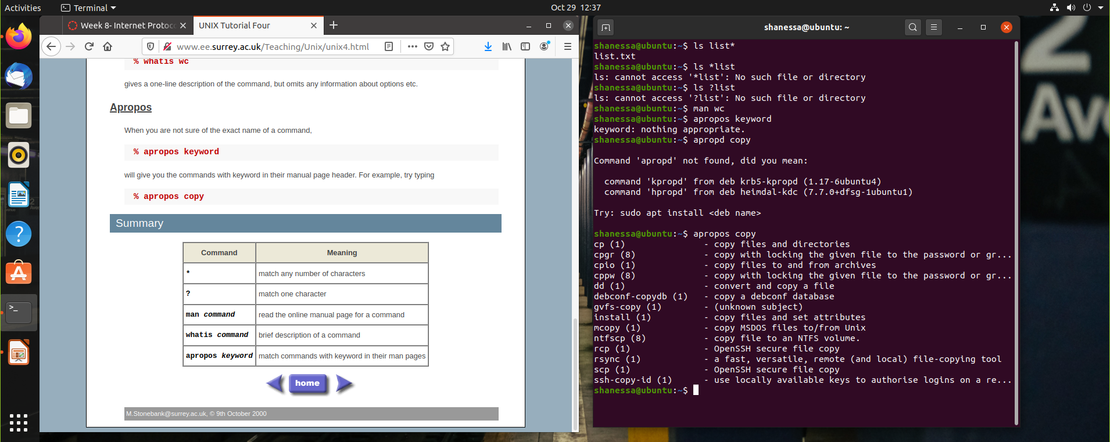

**Task 1b**: Networking exercise

Provide screenshots of all exercises.

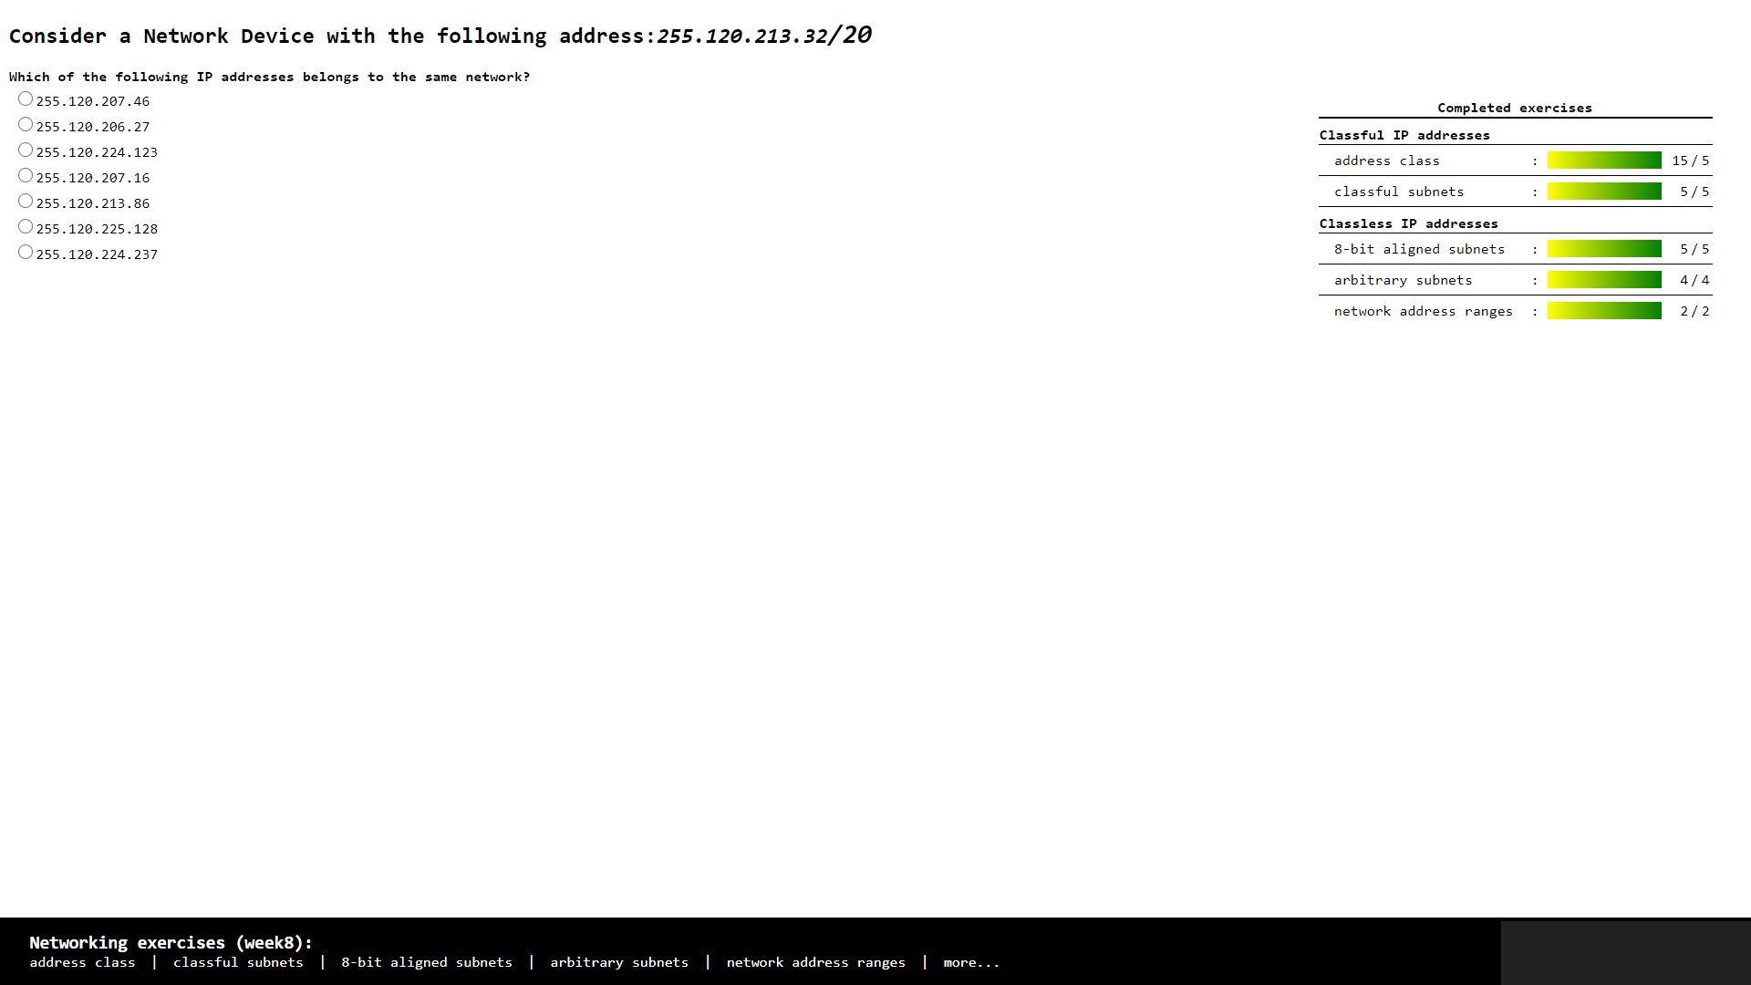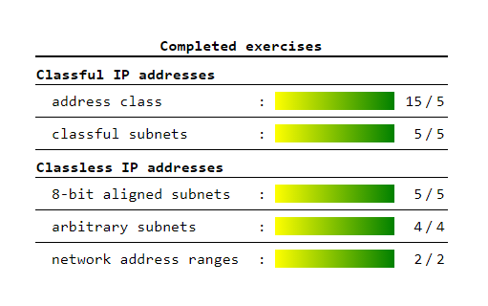

**Task 2:** Build A Simple Netkit Network

1. What is the result of the ping? Can you explain it? Provide a screenshot.

* The result of the ping is “Network is unreachable” because the subnet / the network is different, so the PC can not connect to each other.

1. Look at the ARP entries of your Node1 and Node2. Which command do you use? Which ARP entries are there?

* The command that I used is ARP
* The list on the ARP is empty because the PC are not connected to each other

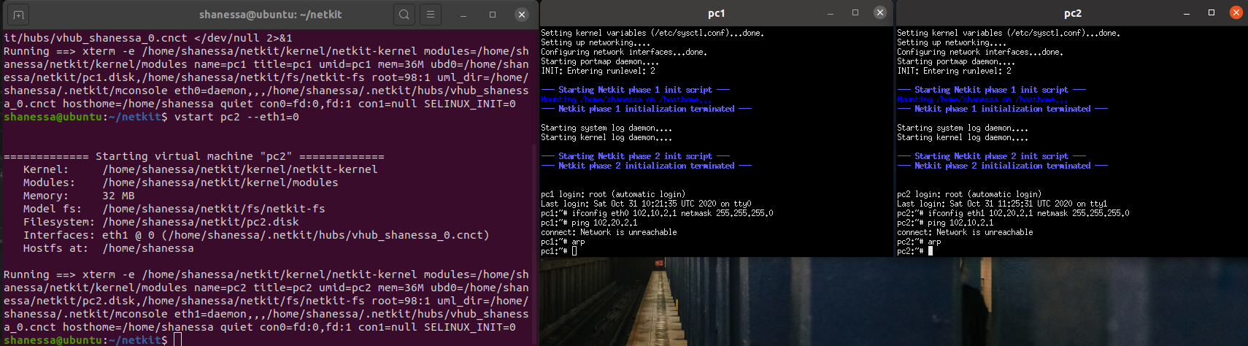

B) Configure the IP addresses of the 2 nodes by using the “ip” command explained in the theory lesson.

1. Node1 has an IP address 102.10.2.1/10
2. Node2 has an IP address 102.20.2.1/10

Check whether your configuration was successful by using ping command between these two nodes.

1. What is the result of the ping? Can you explain it? Provide a screenshot of your configured interfaces.

* The result of the ping is succeeded, it’s working. The PC are connected to each other.

1. Look at the ARP entries of your Node1 and Node2. Which ARP entries are there?

* The ARP of PC 2 already on the PC 1 and vice versa.

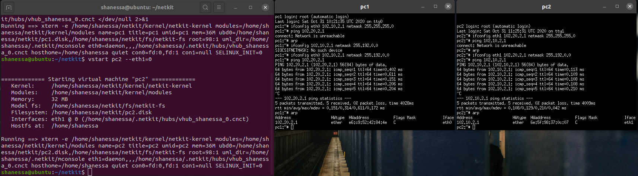

C) Configure both nodes to have a subnet mask 255.255.255.0, and change the IP address of Node2 in such a way that the ping between them is successful.

1. Provide a screenshot of your configuration and successful ping.
2. After successful ping ARP entries of both nodes should be changed. Provide a screenshot of the new ARP situation and explain it. What is the command to clear the ARP cache again

* I changed the IP address of PC 2 and the ARP list showed us the new IP address of PC 2 on the PC 1. And when we want to clear the ARP cache we can use command “arp -d and put the IP address”, e.g. arp -d 102.10.2.2

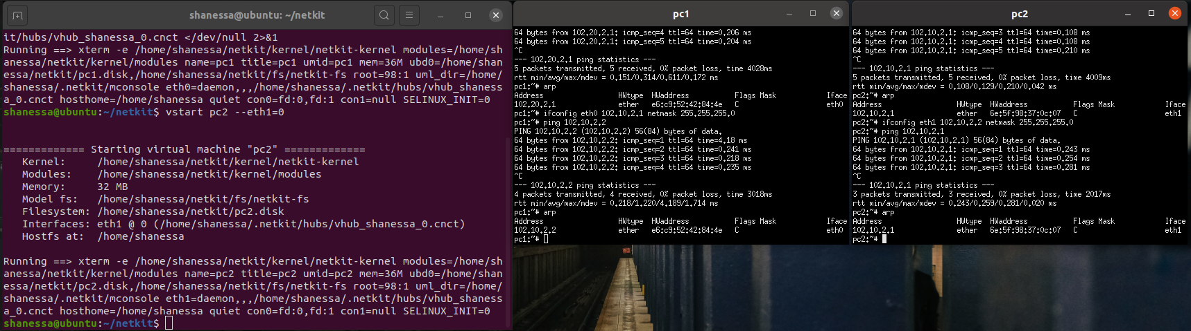

**Task 3**: Configuring Network

Table 1 : IPv4 address ranges per student group

|  |  |  |  |
| --- | --- | --- | --- |
| Group | LANA | LANB | LANC |
| 1 | 10.1.0.0/16 | 172.16.1.0/24 | 192.168.1.0/24 |
| 2 | 10.2.0.0/16 | 172.16.2.0/24 | 192.168.2.0/24 |
| … | | | |
| n | 10.n.0.0/16 | 172.16.n.0/24 | 192.168.n.0/24 |

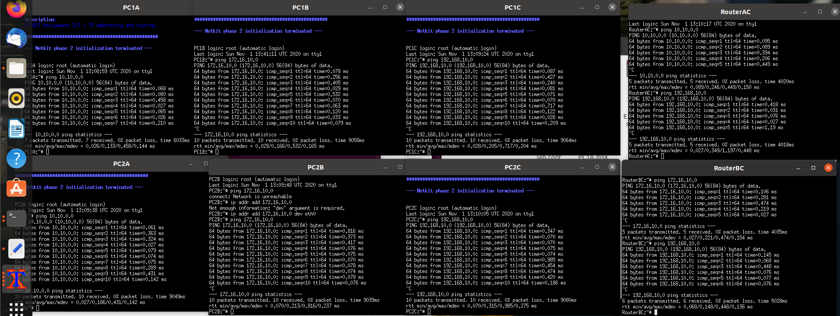

**Task 4**: CIDR IP Addressing Exercises

1. Suppose we have IP address 122.33.196.145/24

Fill in the following items for this address:

1. Network Address : **122.33.196.0**
2. Broadcast Address : **122.33.196.255**
3. Subnet Mask : **255.255.255.0**

2. Suppose we have IP address 163.249.223.229/25

Fill in the following items for this address:

1. Network Address : **163.249.223.128**
2. First Host : **163.249.233.129**
3. Last Host : **163.249.223.254**
4. Broadcast Address : **163.249.233.255**